Mr SGs Ionising Radiation and Nuclear Processes Notes

-Humans are constantly exposed to radiation from a variety of sources

-While we are adapted to deal with this background level of radiation, larger doses of high energy radiation can be damaging or fatal

-Despite the hazards, there are several useful applications of radiation including nuclear power and nuclear medicine

-Nuclear radiation is emitted in nuclear reactions where atomic nuclei are rearranged

Atomic Structure

-Atoms consist of three subatomic particles; protons, neutrons and electrons

Protons and neutrons are composed of even smaller subatomic particles that we will study further in Year 12

-The protons and the neutrons are referred to as nucleons because they form the nucleus in the centre of the atom

-The electrons are located in the electron cloud

-Protons have a + charge and electrons have a – charge and neutrons are uncharged

-Protons and neutrons are approximately equal in mass, but electrons have a far smaller mass

Atomic forces

-There are four fundamental forces of nature that can act at a distance

Gravitational force: the long-range force of attraction between any two bodies with mass

Strong nuclear force: the short-range attractive force between nucleons

Weak nuclear force: the weaker short-range attractive force between nucleons that is involved in nuclear reactions

Electrostatic force: the long-range force of attraction between unlike charges and repulsion between like charges
-The electrostatic and strong nuclear forces are responsible for holding atoms together

-The electrostatic attraction between protons and electrons prevents electrons from leaving the atom

-The strong nuclear force between nucleons balances the electrostatic repulsion between protons and holds the nucleus together

Atomic & Mass numbers

-An atoms identity is defined by the number of protons in its nucleus e.g. Carbon always has 6 protons, lithium always has 3 protons

-This number is referred to as the Atomic number (Z)

-A substance that contains only one type of atom is called an element

-Atoms of an element always have the same number of protons, but they can have different numbers of neutrons

-Atoms of an element that have a different number of neutrons are called isotopes

-Isotopes are identified by their Mass number (A) e.g. Carbon-12, Nitrogen-14

- Mass number is the number of protons + the number of neutrons

e.g. A = Z + N
A
X
-An atoms symbol is often listed with its atomic number and mass number in the format: Z

-The term nuclide is used to refer to the nucleus of a particular atom (e.g. a Carbon-12 nuclide contains 6 protons and 6 neutrons)

Radioisotopes

-Most atomic nuclei are considered stable as they have remained unchanged for billions of years

-Other nuclei are considered unstable as they can spontaneously transmute (change) into another element or isotope

-These unstable atoms are called radioisotopes

-Radioisotopes may be naturally occurring or a product of artificial transmutation in nuclear reactors or particle accelerators
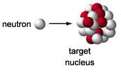

-This can occur by processes such as neutron bombardment, where neutrons are fired at nuclei until a neutron is absorbed by the nucleus

-The addition of a neutron to a stable nucleus can make it unstable

What makes a nucleus stable?
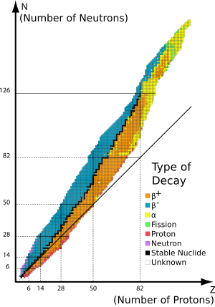

-In any nucleus, nucleons are pushed apart by the electrostatic repulsion of protons

-They are also pulled together by the strong nuclear force between nucleons, but his force can only act over very small distances

-In a stable nucleus, these forces are closely balanced (see black line to the right

-For elements up to around 20, approximately one neutron is needed for each proton, but the number of neutrons needed for each proton increases for larger nuclides

-All elements with more than 83 protons are unstable; the heaviest stable element is Bismuth-209

-Unstable elements will undergo radioactive decay, emitting particles or energy from their nucleus until a stable nucleus is formed

Radioactive Decay

-Early experiments by Ernst Rutherford and Paul Villard identified three types of emission that occurred when radioactive nuclei underwent decay

-Alpha (α) and beta (β) decay involve the emission of particles, while gamma decay (γ) involves the emission of electromagnetic radiation

-The process of radioactive decay can be represented with nuclear equations

Nuclear equations

-In α and β decay, atoms changes into different chemical elements in a process known as transmutation

-Transmutation and nuclear reactions can be represented by nuclear equations in a similar way to how chemical equations are used to represent chemical equations

-Because nuclei are rearranged in nuclear reactions, the atomic number (Z) and mass number (A) of all species must be shown

-The symbols for the reactants (with their A & Z) are shown on the left of the arrow and the symbols of the products are shown on the right

-Nuclear equations obey the following rules:

- The sum of the atomic numbers of the reactants is equal to the sum of the atomic numbers of the products

- The sum of the mass numbers of the reactants is equal to the sum of the mass numbers of the products

-This can also be stated as: ∑Z_{reactants} = ∑Z_{products} and ∑A_{reactants} = ∑A_{products}
-Note that electrons (also called β⁻ particles) have a Z of -1

-The nuclear equation for the α decay of Uranium-238 is shown below as an example

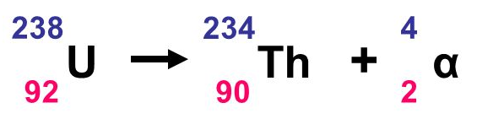
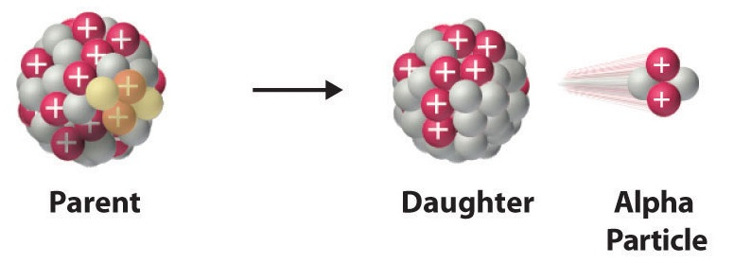
Alpha (α) decay

-Some heavy nuclei emit alpha particles when they undergo radioactive decay

-An alpha particle is composed of two protons and two neutrons (a helium nucleus)

-In alpha decay, the parent nucleus decays to form an alpha particle and a daughter nucleus containing two less protons and two less neutrons than the parent

-Energy is also released, mostly in the form of kinetic energy of the alpha particle

Beta (β) decay

-Beta decay occurs when the nucleus of an atom emits a beta particle

-The beta particle may be a β⁻ or a β⁺ particle, depending on the type of decay

-Nuclei above the line of stability (too many neutrons) tend to undergo β⁻ decay, while nuclei below the line tend to undergo β⁺ decay

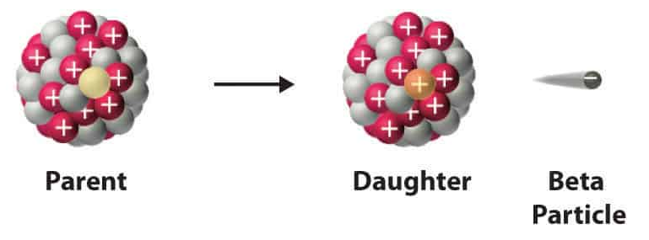
Beta minus (β⁻) decay

-A beta minus particle is an electron

-Beta minus decay occurs when an electron is emitted from the nucleus of an atom (not from the electron cloud)

-When a nucleus has too many neutrons, one can spontaneously change into a proton, and electron and an antineutrino (v), a massless uncharged antimatter particle:

-The antimatter has an atomic number of zero as it is uncharged and a mass number of zero as it has no mass

-The nuclear equation for the beta minus decay of carbon-14 is shown below:

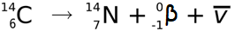
Beta plus (β⁺) decay
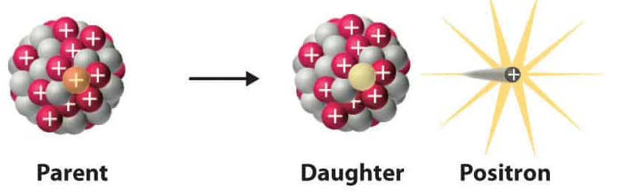
-A beta plus particle is a positron, an antimatter particle identical to an electron but with a positive charge

-Beta minus decay occurs when a positron is emitted from the nucleus of an atom

-When a nucleus has too many protons (e.g. not enough neutrons), one can spontaneously change into a neutron, a positron and a neutrino (v)

Gamma (γ) decay

-When an atom undergoes radioactive decay, the resulting atom often has excess energy that makes it unstable

-These atoms are said to be excited, which can be shown by drawing an asterisk (*) next to its symbol

-Excited atoms release this energy as a gamma ray, a type of electromagnetic radiation

-Gamma rays do not have mass or a charge, as they are not a particle

-The equation for the gamma decay of cobalt-60 is shown below:

Properties of α, β, and γ radiation

-The properties of the different types of radiation is determined by their mass, energy, speed and charge

-These factors affect the degree to which the different types of radiation can ionise substances and penetrate through matter

-The differences in ionising and penetrating ability, mean that different measures are required to protect against them

Mass: A measure of how much matter something contains, measured in kilograms or atomic mass units (1 u = mass of one nucleon = 1.66 x 10⁻²⁷ kg)

Energy: A measure of the ability to perform work, measured in Joules or electron volts
(1 eV = energy gained by an electron accelerated by a 1 V potential difference = 1.6 x 10⁻¹⁹ J)

Speed: A measure of distance travelled per unit of time, measured in meters per second, or as a fraction of the speed of light (c = speed of light = 3.00 x 10⁸ m s⁻¹)

-As v = E_{k} speed increases as energy increases and mass decreases
2m

Charge: A property of matter causing electric effects
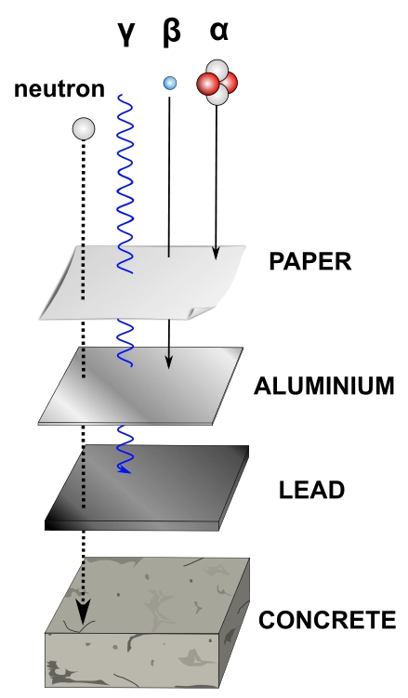

-Charged particles can be deflected by electric and magnetic fields and can be repelled by like charges, reducing their penetrating ability

Ionising ability: The ability of particles or radiation to ionise matter, generally by removing electrons in collisions

-Ionising ability increases with increasing charge and decreasing speed

Penetrating ability: A measure of how easily radiation passes through matter

-Penetrating ability is greatest for radiation with a low ionising ability, e.g. faster moving, uncharged radiation that does not readily interact with matter

 | α | β | γ
mass | high (~ 4 u) | low (~1/1800 u) | none
energy | ~5-10 MeV | ~1 MeV | ≤1 MeV
speed | ≤ 0.1 c | ~ 0.9 c | c
charge | +2 | -1 or +1 | 0
ionising ability | very high | low | very low
penetrating ability | very low (~10µm) | a few mm | high
Can be stopped by | a few cm of air | 1-2 mm of Al | A few cm of Pb

Half-Life

-Different radioisotopes decay at different rates

-While it is impossible to predict how long an individual nucleus will take to decay, the decay of a larger sample can be predicted mathematically

-A decay curve is a plot showing how the number of nuclei in a radioisotope sample remain as time progresses

-Half-life (t_{1/2}) is the time it takes for half of the nuclei in a sample of a radioisotope to decay

-Any individual nucleus has a 50% chance of decaying in each half-life

-The number of nuclei remaining after a given number of half-lives can be calculated using the formula:

N = N₀ (½)^{n}

where N = number of radioactive nuclei remaining
N₀ = initial number of radioactive nuclei
n = number of half-lives elapsed

-The number of half-lives elapsed in a given period of time can be calculated using the formula:

n = T where n = number of half-lives, T = period of time
t_{1/2} and t_{1/2} = half-life

Activity (A)

-Activity is a measure of a samples rate of decay

-It has units of becquerels (Bq), where 1 Bq = 1 disintegration per second

A = N where A = activity (Bq), N = number of disintegrations
t and t = time (s)
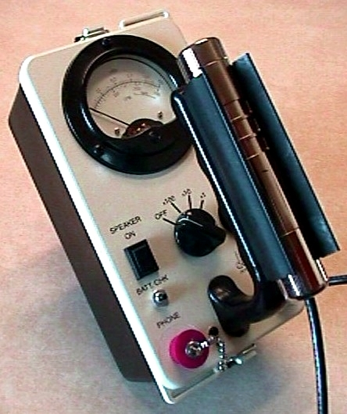
-The activity of a sample can be measured using a Geiger counter

-A samples activity decreases as it decays, with its activity proportional to the number of nuclei remaining

-As the number of nuclei remaining is a function of the samples half-life, the half life formula can be stated in terms of activity:

A = A₀ (½)^{n}

where A = activity of radioactive nuclei remaining
A₀ = initial activity of radioactive nuclei
N = number of half-lives elapsed

Decay Series

-When a radioisotope undergoes decay, the daughter nucleus is often unstable and will undergo further radioactive decay

-Successive decays will occur until a stable nucleus is formed

-These successive decays and the half-lives of the radioisotopes formed can be shown in a decay series, where atomic number is plotted on the x-axis and mass number is plotted on the y-axis

Radiation Effects
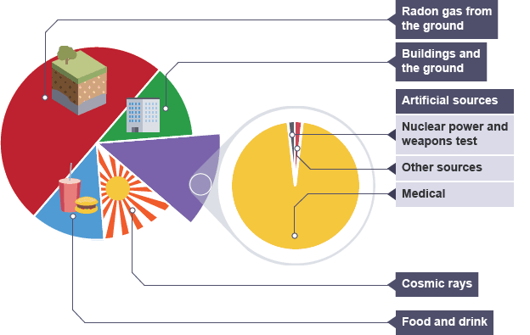
-Humans are constantly exposed to low levels of background radiation, but higher doses of ionising radiation can cause tissue damage, leading to cancer or radiation sickness

Background radiation: the relatively low levels of ionising radiation that humans are constantly exposed to due to the radioactivity of earth’s environment

Ionising radiation: radiation that has enough energy to remove electrons from atoms, causing a change it the chemical structure of materials

-Only the most energetic electromagnetic radiation is ionising; EM radiation with a frequency above 2 x 10¹⁶ Hz (UV-B, X-rays and γ rays)

-When living tissue is exposed to radiation, the damage caused depends on both the dosage and type of the radiation

Absorbed dose

-Radiation damage increases as increasing amounts of energy are absorbed in a given mass of tissue

-The unit of absorbed dose is the gray (Gy), where 1 Gy = 1 Jkg⁻¹

AD = E where AD = absorbed dose (in Jkg⁻¹ or Gy), E = energy absorbed (J)
m and m = mass of tissue (kg)

Dose Equivalent

-Different types of radiation cause different levels of harm, due to differences in how they interact with and ionise tissue

-Less penetrating and more ionising forms of radiation like α particles will ionise a greater number of molecules in a smaller region of tissue, causing greater damage

Quality factor (QF): A weighting of the biological impact of each type of radiation

-The quality factors of various types of radiation are listed in your data sheet
Dose equivalent (DE): A measure of radiation absorbed that takes the type of radiation into account

-It has units of Sieverts (Sv)

-Dose equivalent is the most common way to measure radiation doses

DE = AD x QF where DE = dose equivalent (Sv), AD = absorbed dose (Gy) and QF = quality factor
Effects of radiation on humans

-While lower doses of radiation increase cancer risk due to the DNA damage caused, higher doses can cause radiation sickness and death

-5000 mSv (5 Sv) is the dose equivalent that is fatal for 50% of those exposed (LD₅₀)

-There are also medical uses for radiation

-Radioactive tracers can be used to detect cancers in humans and radiation therapy can be used to deliver a fatal dose of radiation to cancer cells

Nuclear Reactions

-Transmutations can occur naturally or artificially

-Alpha and beta decay are examples of spontaneous transmutation, where one element is transformed into another in a natural process

-Transmutations can also occur when a nucleus is deliberately struck by another nucleus or a subatomic particle, such as an α particle

-This is known as artificial transmutation

-Artificial transmutations include the nuclear reactions that occur in nuclear reactors and nuclear weapons

-In these reactions, larger nuclei can split into smaller nuclei (fission) or smaller nuclei can join together into larger nuclei (fusion), releasing huge amounts of energy

Fission
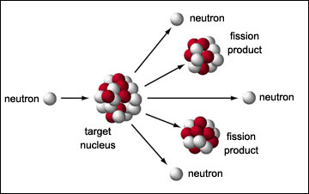
-Electrostatic repulsion between nuclei that contain protons (including α particles) makes it difficult to induce nuclear reactions by firing them at each other

-Neutrons are uncharged, so they do not experience electrostatic repulsion

-This makes it much easier to induce a nuclear reaction by firing neutrons at a target nucleus

-In fission reactions, a target nucleus absorbs a neutron before splitting into two or more pieces, often releasing additional neutrons

-A nuclide that can undergo fission is said to be fissile

-All fissile nuclides have high atomic numbers (e.g. ²³⁵U, ²³⁹Pu) and most do not occur naturally

-Nuclides that need to absorb a very high energy neutron to undergo fission are said to be fissionable, but non-fissile

-The nuclear equation for one of the possible fission reactions of ²³⁵U is shown below:

-Many of the fission products produced in these reactions are also reactive (e.g. form the hazardous components of nuclear waste)

-In some circumstances, the neutrons released in nuclear fission can cause other nuclei to undergo fission

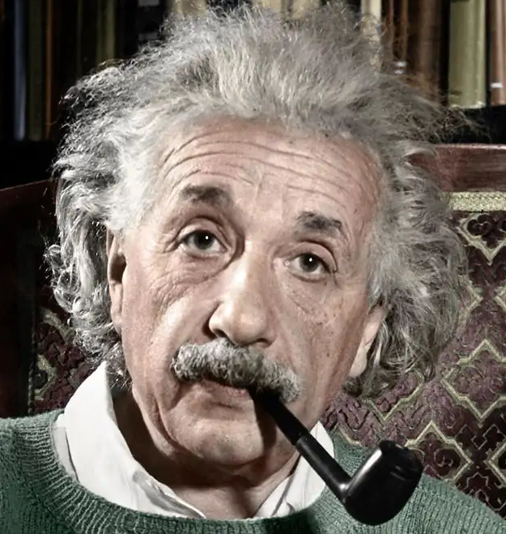
Energy release in nuclear reactions

-The mass of a nucleus is always less than the mass of its individual nucleons

-In fission reactions, the mass of the products of the reaction is always less than the mass of the reactants

-Albert Einstein explained how mass can change during fission and fusion and how the changes in mass explain the energy released in these reactions

-Einstein linked the mass defect observed in nuclear reactions to changes in the energy that binds nucleons together within the nucleus

-He showed that mass can be converted into energy (and vice versa) under some circumstances

Binding energy: is the energy required to split a nucleus into its individual nucleons (e.g. to split a helium nucleus into two protons and two neutrons)

-When a large nuclei decays, the mass is lost and energy is released due to changes in binding energy

-Only a very small proportion (~0.1%) of the mass of a fissile nucleus can be converted into energy, as most of the mass of a nucleus is due to the mass of the nucleons it contains

-Einstein quantified the mass-energy relationship with the equation:

ΔE = Δm c² where ΔE = energy (J), Δm = mass defect (kg) and
c = the speed of light (3.0 x 10⁸ ms⁻²)

Atomic mass units (u) & electronvolts (eV)

-It is often to measure mass defect in kilograms, as the mass loss in a nuclear decay is typically extremely small (e.g. the fission of a Pu-239 nucleus produces a mass defect of 3.07 x 10⁻²⁸ kg)

-The atomic mass unit (u) is often a more suitable measure of mass

-One atomic mass unit is equal to 1/12 of the mass of a Carbon-12 atom (very close to the mass of a single proton or neutron)

1 u = 1.66 x 10⁻²⁷ kg

-It is also impractical to measure the energy released in nuclear reactions in Joules, as the energy released in the decay of a single nucleus is so small (e.g. the fission of a Pu-239 nucleus releases 2.76 x 10⁻¹¹ J)

-The electronvolt (eV) is a more suitable unit of energy in many cases

-One electronvolt is equal to the energy an electron would gain if it was accelerated by a voltage of 1 V

1 eV = 1.60 x 10⁻¹⁹ J

-When mass defects are expressed in amu and energy is expressed in MeV (Mega electronvolts, 1 MeV = 10⁶ eV), Einstein’s equation can be expressed in terms of the amount of energy that is equivalent to a given mass defect

Mass energy equivalent: 1 u = 931 MeV

Nuclear fission: nuclear reactors and weapons

-To obtain useful amounts of energy from nuclear fission, huge numbers of nuclei must undergo fission

-To do this, it is necessary to generate a chain reaction, where the neutrons released in fission cause the fission of additional nuclei

-These reactions occur to different degrees in nuclear reactors and nuclear weapons

-The reactions we will study involve the fission of ²³⁵U and ²³⁹Pu (the fissile isotopes of uranium and plutonium)

Chain reactions
-When ²³⁵U undergoes fission, it releases either 2 or 3 (mean = 2.47) neutrons

-For a chain reaction to be sustained, enough of these neutrons must be absorbed by other fissile nuclei

-If each fission can induce the fission of two other nuclei, the amount of fission reactions occurring and the energy released will grow exponentially

-Whether this occurs depends on the proportion of fissile atoms present in the nuclear fuel

Nuclear fuel

-For a chain reaction to occur, a sufficient percentage of the neutrons released by fission must be absorbed by fissile nuclei

-This can only occur if a sufficient proportion of the atoms present in the fuel are fissile

-Naturally occurring uranium, consists of about 99.7 % non-fissile ²³⁸U and 0.7% fissile ²³⁵U

-The percentage of fissile nuclei is too low to sustain a chain reaction

-To be used as nuclear fuel, the uranium ore must be enriched to ~4% ²³⁵U for nuclear reactors or ~90% for nuclear weapons

-Enrichment generally occurs by ultracentrifuge or electromagnetic separation or gaseous diffusion separation
Critical Mass
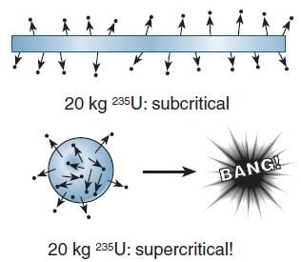

-If a piece of ²³⁵U is too small, most of the neutrons released in fission will pass out of the material rather than being observed

-This can also happen if it is in a shape with a high surface area (e.g. a thin flat sheet)

Critical mass: the minimum spherical mass of enriched material required for sustained fission

-Masses smaller than the critical mass are said to be subcritical and masses larger than the critical mass are said to be supercritical

-Nuclear weapons (fission bombs) are detonated by firing two or more subcritical masses at one another to form a single supercritical mass which explodes

Nuclear Reactors

-Nuclear power plants are very similar to other types of power generation in that they heat water to produce steam which drives a turbine in a generator

-In a nuclear reactor, the heat is generated by fission of ²³⁵U (and ²³⁹Pu in some reactors)

-The nuclear chain reaction is carefully controlled to produce enough energy to heat the water without causing an explosion

-Nuclear reactors contain the following components:

Fuel rods: long thin rods of fissile material

Moderator: material that slows the neutrons so they can be more readily captured

Control rods: material that absorbs neutrons to slow the chain reaction

Coolant: absorbs heat energy released in fission and transfers it to water to produce steam

Fuel rods
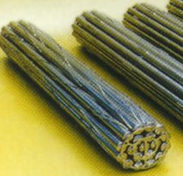
-Fuel rods typically consist of ~96% ²³⁸U and 4% ²³⁵U

-The ²³⁵U undergoes fission, releasing energy and neutrons

-While ²³⁸U is not fissile, it can absorb a neutron and form the fissile isotope ²³⁹Pu which can undergo fission, releasing more energy and neutrons

-“Fast breeder reactors” take advantage of this reaction to produce more fissionable fuel (in the form of ²³⁹Pu)

Moderators

-The fast moving neutrons released in fission of ²³⁵U can be more readily captured by fissile nuclei if they are slowed down

-A moderator is a material with small nuclei that is able to slow (moderate) these neutrons when they collide

-Typical moderators include graphite, water, heavy water (containing deuterium ²H) or carbon dioxide

Control rods
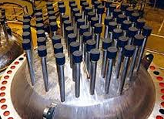
-If the nuclear chain reaction is able to continue in an uncontrolled manner, it will grow exponentially releasing more and more energy any neutrons

-Control rods act to control the rate of fission by absorbing neutrons into their nuclei, preventing those neutrons from causing addition fission reactions

-They typically consist of cadmium or boron steel

How a nuclear reactor works

-A nuclear reactor core consists of the fuel and control rods inserted into the moderator

-The control rods are raised or lowered into the core to control the rate of fission

-The heat produced by fission heats the coolant which is piped to a heat exchanger/boiler

-Heat from the coolant is used to boil water to produce steam which drives the turbines that power the generator

Nuclear waste

-While nuclear power is one of the safest power sources in terms of deaths per GW of electricity generated, it does produce waste that remains radioactive for thousands of years

-This waste mostly consists of fission fragments produced in the decay of uranium and plutonium

Nuclear Fusion

-Nuclear fusion occurs when two smaller nuclei fuse together to form a larger nucleus

-As with fission, the mass of the fusion products is slightly less than the mass of the reactants, with the excess mass being converted into energy

ΔE (J)= Δm c² or ΔE (eV)= Δu x 931

-Fusion releases more energy per nucleon than fission and does not produce radioactive waste (e.g. fission fragments)

-Fusion is very difficult to achieve, as the electrostatic force of repulsion between positively charged nucleons must be overcome in order to force the nuclei close enough so that the (very short range) strong nuclear force can take over

-To overcome this repulsion, the reactants must have extremely high kinetic energies (e.g. hundreds of millions of degrees, as found in stars)

-In our sun, huge temperatures and gravitational pressure forces hydrogen and helium isotopes to fuse in the following reactions

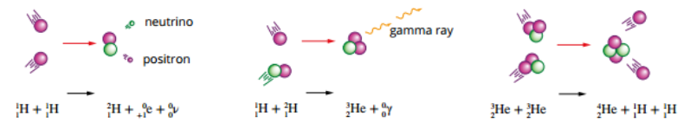

Binding energy and fusion

-As we saw for fission, the mass of a stable nucleus is less than the mass of its individual nucleons

-As shown by Einstein, this mass defect can be converted into energy using ΔE = Δm c²

-This energy required to break a nucleus apart is the binding energy

-Nuclei with a higher binding energy are more stable as they take more energy to break apart

-Each nucleus has a different binding energy (usually shown as binding energy per nucleon)

-Iron-56 has the highest binding energy per nucleon (e.g. is the most stable nucleus) with binding energy decreasing as mass number decreases or increases
-Nuclei with a mass number between 40 and 80 are very stable due to their high binding energy

-Nuclei larger than iron can undergo fission, releasing the extra binding energy as a lighter, more stable nuclei are formed resulting in a mass defect

-Nuclei smaller than iron can undergo fusion, releasing the extra binding energy as a larger more stable nucleus (that has a lower mass than the combined mass of the reactants) is formed

-For very small nuclei, the binding energy per nucleon increases dramatically as mass number increases, explaining the much larger energy released in fusion compared to fission

Applications of fusion
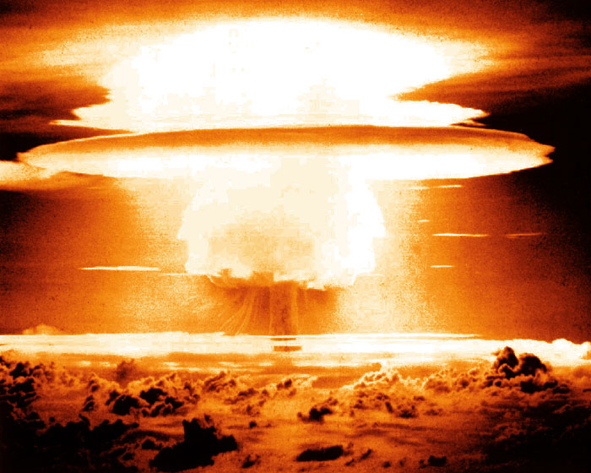
-Fusion occurs in hydrogen bombs (also called thermonuclear weapons), an immensely destructive form of nuclear weapon

-In fusion weapons, conventional nuclear bombs are used as a fuse to produce the immense heat required for fusion

-Fusion reactors have been a target of research, due to their potential to generate electricity without producing large amounts of harmful nuclear waste or greenhouse gases

-The extreme temperatures required for fusion make it very difficult to design these reactors and commercial fusion reactors have not yet been developed

